City of Deer Park
7777 Blue Ash Rd
Deer Park OH, 45236
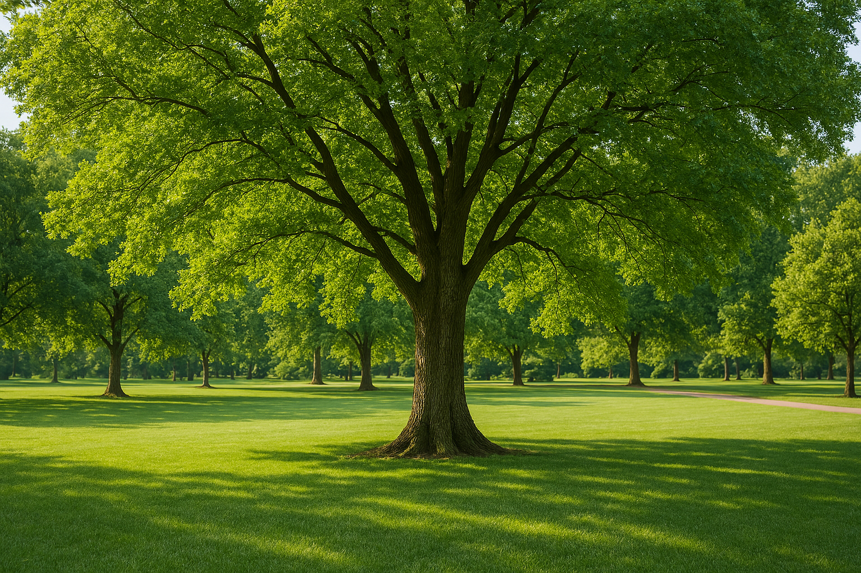

DEDICATION MEMORIAL BRCIK

Brick Order Form Brick Cost: $30.00 plus S&H

Dedication Memorial bricks and trees are a great way to memorialize a loved one for generations to come. *Note* At this time a tree must be purchased along with the brick. Tree prices vary, please contact the city office for prices and availability. Please make checks payable to “The City of Deer Park”.

The bricks may contain up to 14 characters and spaces on each of the three lines. To order, fill out the Order Form below and submit with your check to address shown above.

You may donate without purchasing a brick. Bricks orders are sent for inscription annually, in early April.

Thank you.

Your Name: ____________________________________________ Phone: _________________

Inscription:

